Project Design Phase-II
Data Flow Diagram & User Stories
Date | ________________
Team ID | ___SWTID-2026-6616_____________
Project Name | Auto Ticket Classification using Flow Designer in Skill Wallet – ServiceNow Course
Maximum Marks | 4 Marks

Data Flow Diagrams:
A Data Flow Diagram (DFD) is a visual representation of how information moves through a system. For this project, the DFD shows how a ticket is created in Skill Wallet, processed by ServiceNow Flow Designer, classified using defined rules, and routed to the appropriate support team.
Example: DFD Level 0 (Industry Standard)
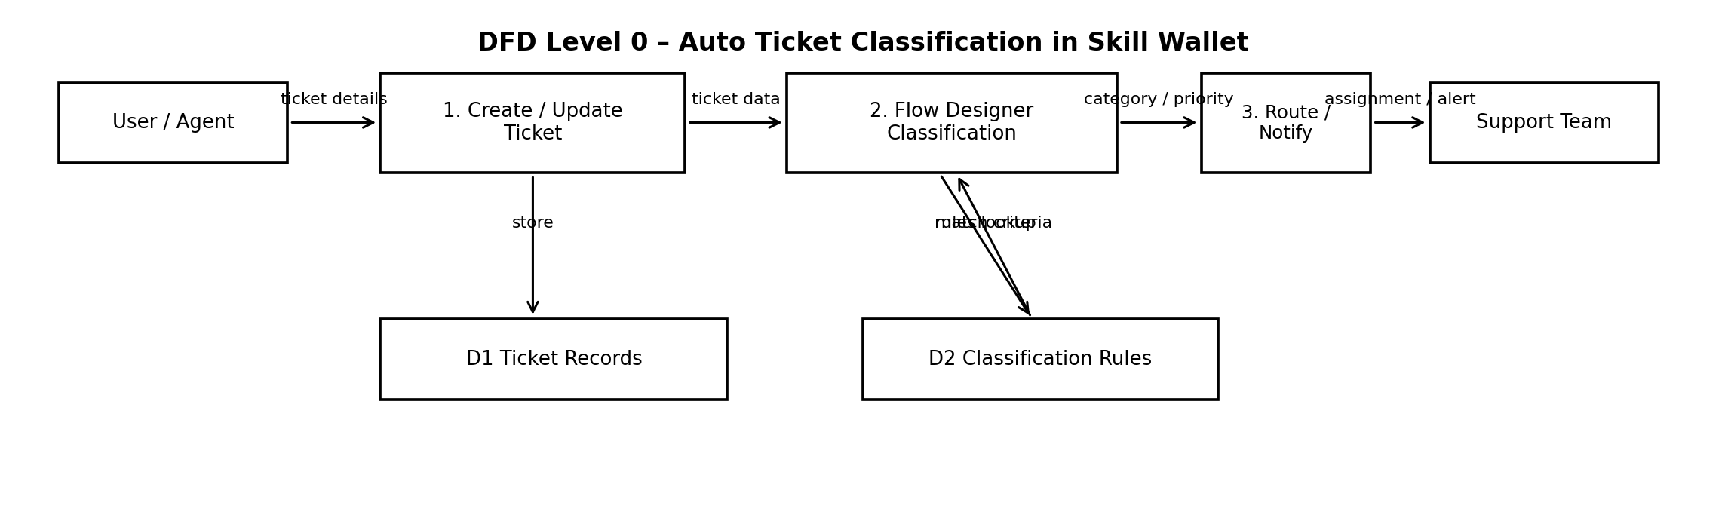
User Stories:
US-01: As a Skill Wallet user, I want to create a ticket with relevant details so that my issue can be recorded and tracked.
US-02: As a support agent, I want tickets to be automatically classified by category and priority so that manual classification is reduced.
US-03: As a support team member, I want classified tickets to be routed to the correct team so that issues reach the appropriate resolver.
US-04: As an administrator, I want to define and test classification rules in Flow Designer so that ticket automation remains accurate and maintainable.
[Insert Screenshot: Flow Designer Workflow / Skill Wallet Ticket Form]

